Network Architecture and Protocol Lab

Booklet 4
Submitted by: Jamil Ahmed
Neptun Code: JZT75Y

4.1

A) Collision and Broadcast Domains
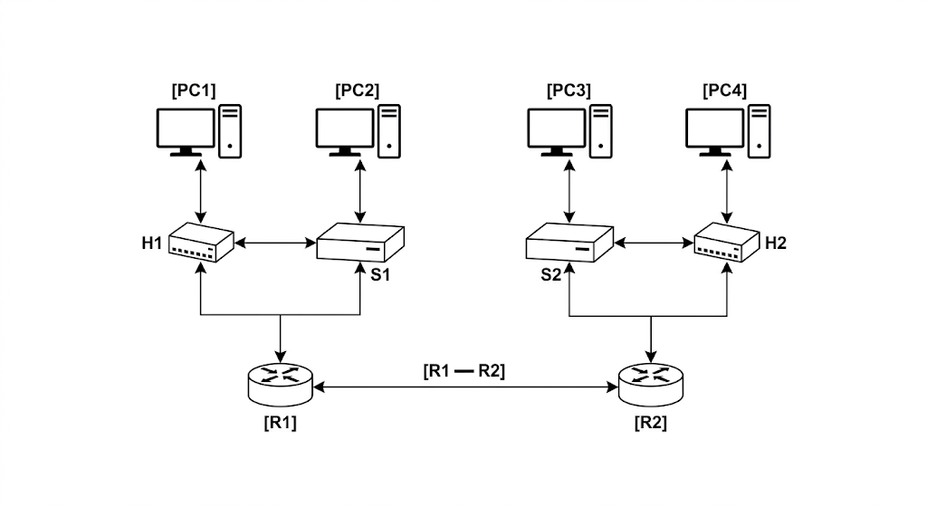The topology contains 7 collision domains. Each port on a switch and router acts as an independent collision domain, whereas a hub treats all connected devices as a single domain. Specifically, on the left, the segments between PC2-S1, S1-H1 (including PC1), and S1-R1 count as three domains. Mirroring this on the right, the segments between PC3-S2, S2-H2 (including PC4), and S2-R2 add another three. The final domain is the point-to-point link connecting R1 and R2.
In terms of broadcast domains, there are 3. Everything connected to the internal interface of R1 (PC1, PC2, H1, S1) forms the first domain, while everything connected to the internal interface of R2 (PC3, PC4, H2, S2) forms the second. The direct link between the two routers constitutes the third broadcast domain.

B) Effect of Replacing Switches with Hubs
If switches are replaced with hubs, the behavior of the network changes significantly.
Hubs do not separate collision domains, meaning all connected devices share the same medium. As a result, the entire left side becomes one collision domain, and the entire right side becomes another collision domain, with the link between the two routers forming a third collision domain.
Thus, the number of collision domains reduces to three. However, broadcast domains remain unchanged at three, since routers still separate them.

4.2

A)
The routing table is not empty after assigning IP addresses. When an IP address is configured on an interface, the operating system automatically adds entries for directly connected networks.
For example, if an interface is assigned an address in the 10.0.1.0/24 network, a route to this network is automatically added. Additionally, a loopback route is also present by default.

B)
Configuring routing on only one node is not sufficient because communication in a network is bidirectional.
If only one node has a route to the destination, packets may reach the destination, but the reply packets will not know how to return. Therefore, routing information must be configured on all participating nodes to ensure proper two-way communication.

C)
The address 10.0.4.25/24 cannot be assumed to be a valid default gateway.
A default gateway must be the IP address of a router interface that is reachable within the same subnet. While 10.0.4.25 is a valid host address, it is not necessarily assigned to a router. Therefore, it cannot be used as a default gateway unless it is specifically configured on a router interface within the same network.

4.3

A) Subnets and Netmask
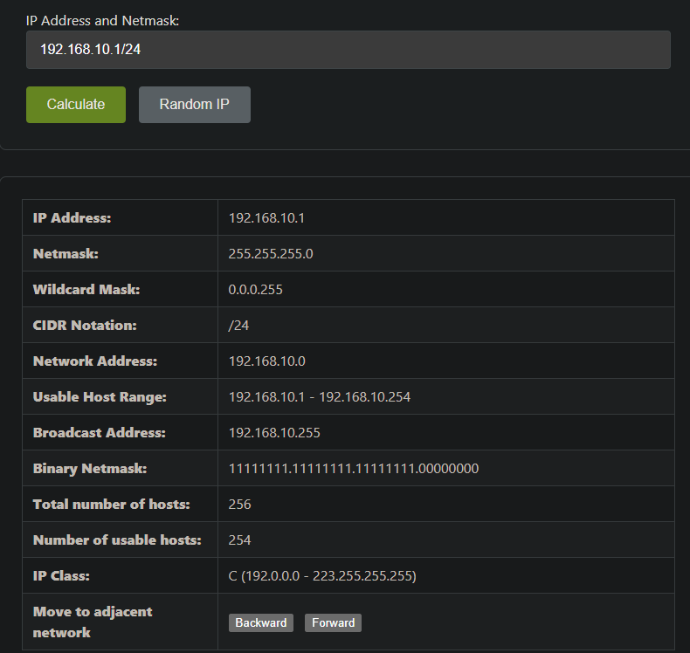
Starting from the network 192.168.10.0/24, borrowing three bits results in a new prefix length of /27. Each subnet contains 32 IP addresses, out of which 30 are usable for hosts. The resulting subnets are as follows:
192.168.10.0/27, covering the address range 192.168.10.0 to 192.168.10.31
192.168.10.32/27, covering the address range 192.168.10.32 to 192.168.10.63
192.168.10.64/27, covering the address range 192.168.10.64 to 192.168.10.95
192.168.10.96/27, covering the address range 192.168.10.96 to 192.168.10.127
192.168.10.128/27, covering the address range 192.168.10.128 to 192.168.10.159
192.168.10.160/27, covering the address range 192.168.10.160 to 192.168.10.191
Although eight subnets are created in total, only the first six are used to satisfy the requirement. Each of these uses the netmask 255.255.255.224.

B) Referring to First Four Subnets Together
It is possible to refer to the first four subnets together using route summarization, also known as supernetting.
Since all four subnets originate from the same /24 network and are contiguous, they can be summarized back into the single network 192.168.10.0/24. This reduces the number of routing entries and simplifies routing tables.

4.4

A)
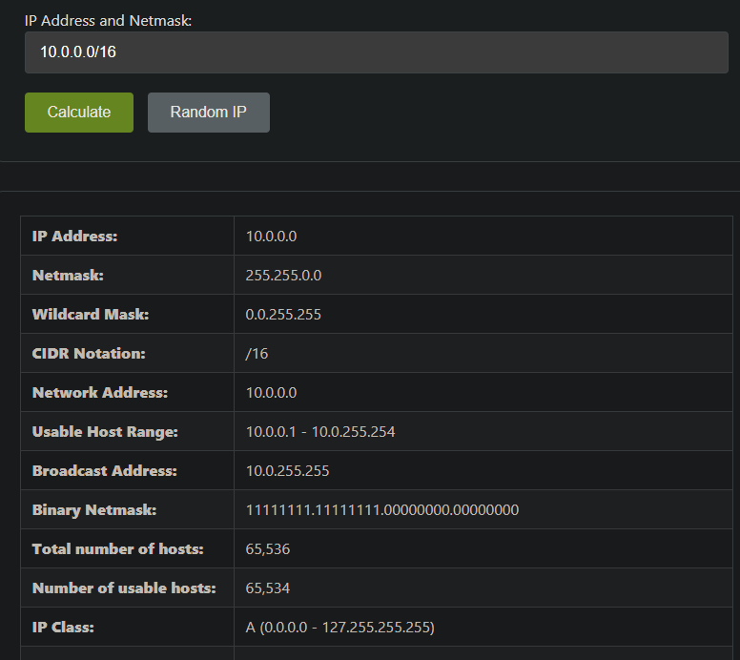
Using the base network 10.0.0.0/16, subnets are allocated according to host requirements using VLSM.
The largest requirement, 6000 hosts, is assigned 10.0.0.0/19. The next requirement, 3500 hosts, is assigned 10.0.32.0/20. The 2000-host requirement is assigned 10.0.48.0/21, and the 1500-host requirement is assigned 10.0.56.0/21.
Requirement | Subnet | Mask
6000 hosts | 10.0.0.0/19 | 255.255.224.0
3500 hosts | 10.0.32.0/20 | 255.255.240.0
2000 hosts | 10.0.48.0/21 | 255.255.248.0
1500 hosts | 10.0.56.0/21 | 255.255.248.0

B)
If subnet requirements arrive over time and are allocated without planning, fragmentation of address space can occur. In such cases, it may become difficult or impossible to allocate a large contiguous block later. Therefore, it is important to allocate subnets starting with the largest requirement to avoid fragmentation and ensure efficient usage.

C)
The /16 network provides a total of 65,536 addresses. The allocated subnets consume 16,384 addresses.
Subtracting the used addresses from the total leaves 49,152 addresses remaining. So, approximately 49,000 addresses are left with a thousand precision. These can be used for future subnetting.

D)
From the remaining address space, the largest possible contiguous subnet must be a power of two.
The closest suitable block is 2^(32-17) = 32,768 addresses (32,766 usable), which corresponds to a /17 subnet. This is because 32,768 is the largest power of 2 that is less than the number of remaining addresses (49,152). Therefore, the largest possible remaining subnet is 10.0.64.0/17.

